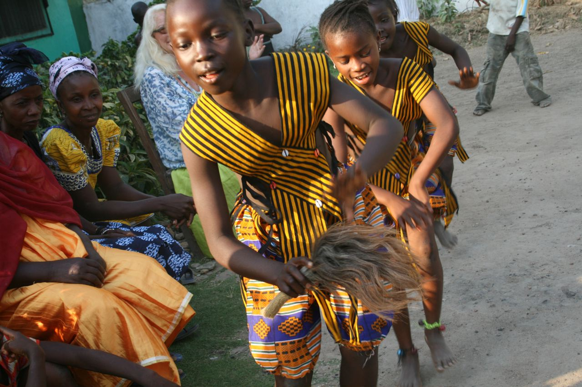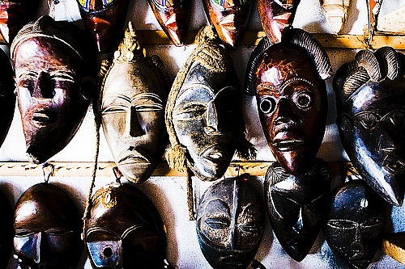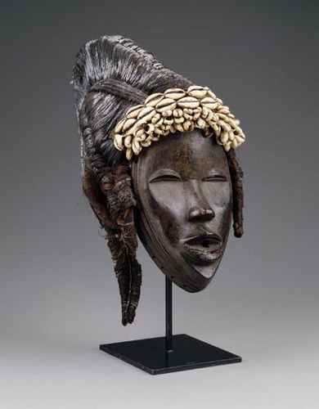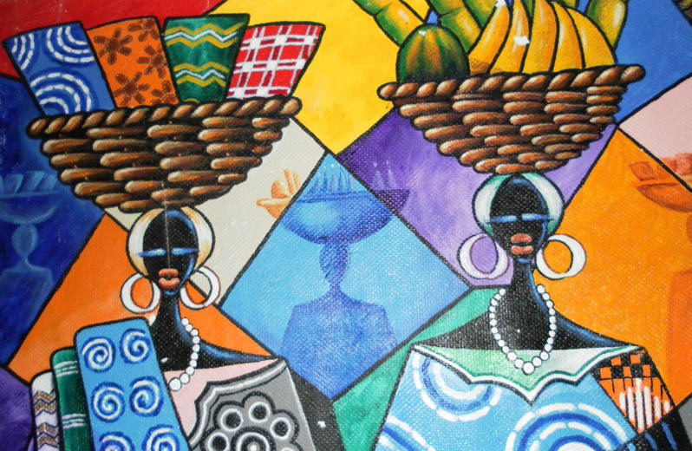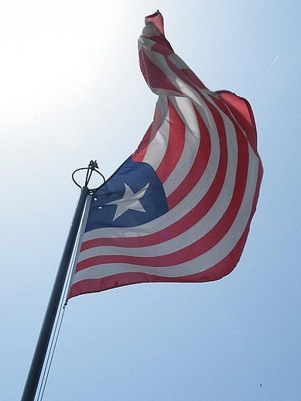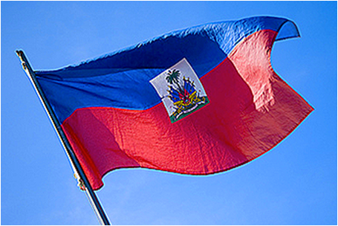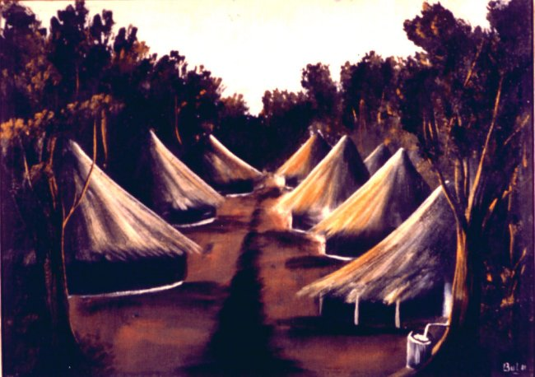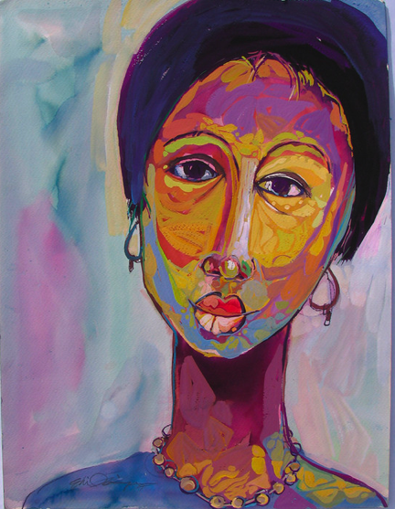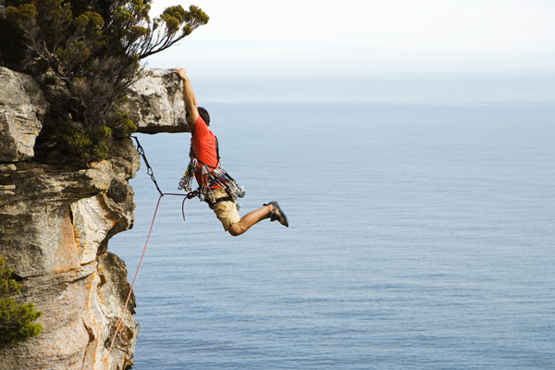 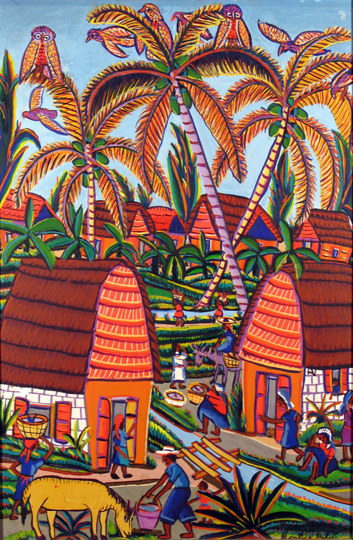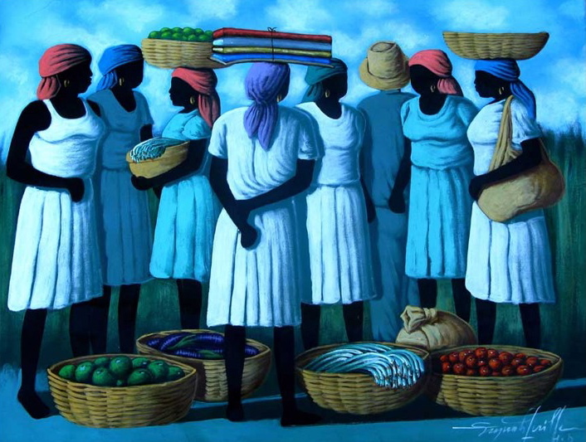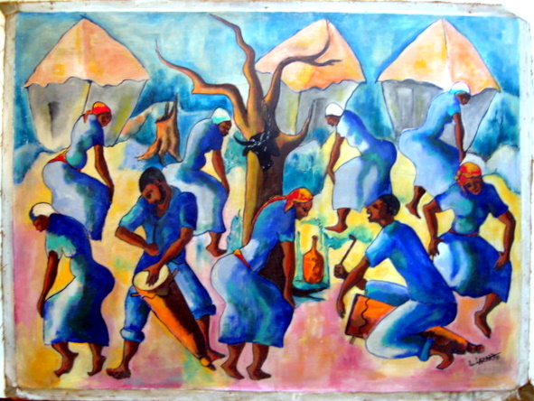 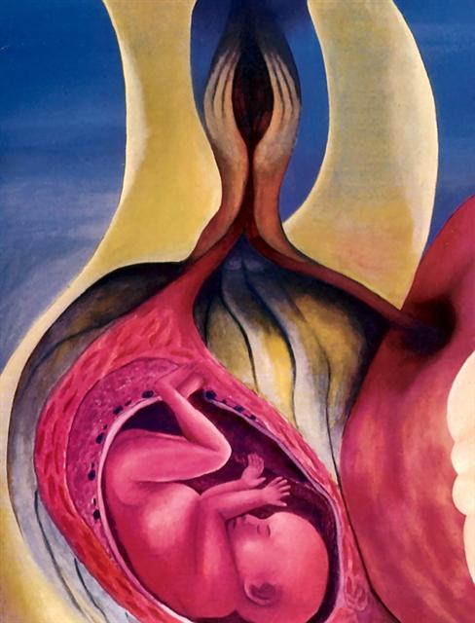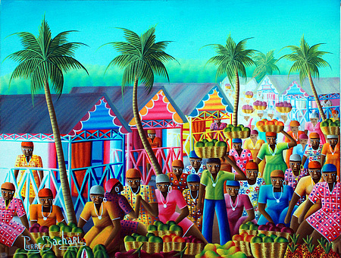 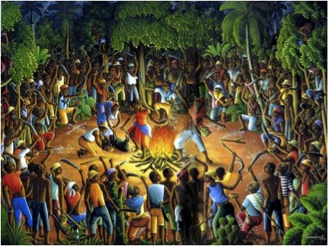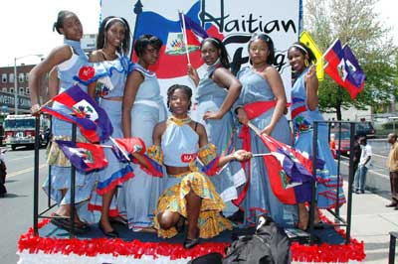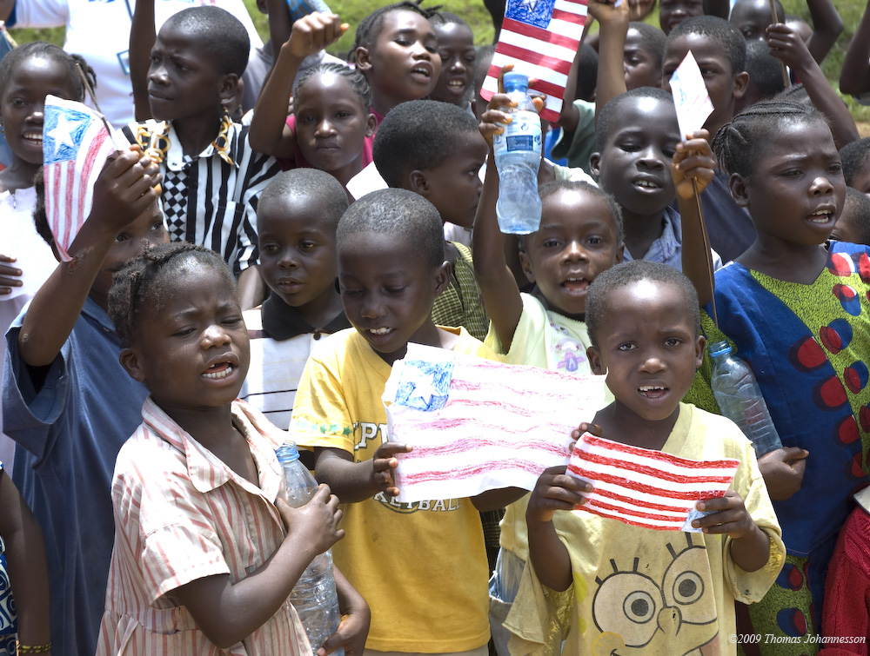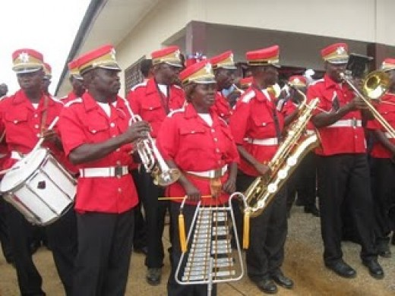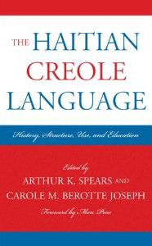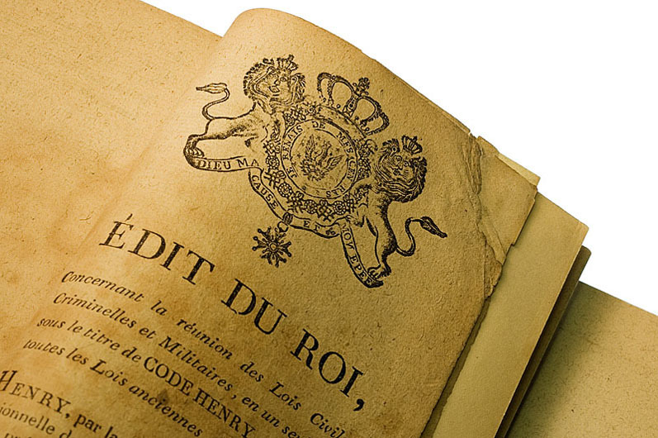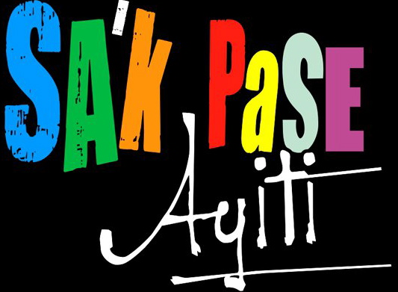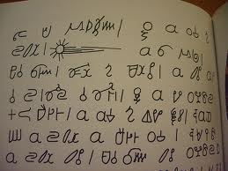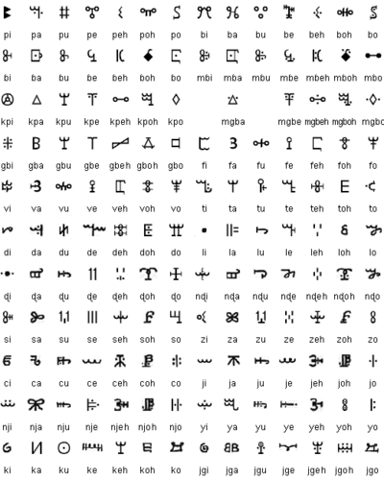 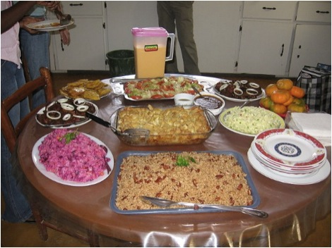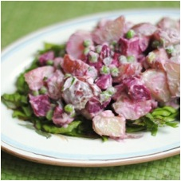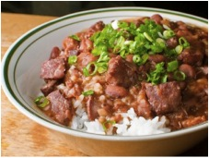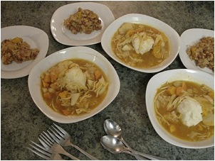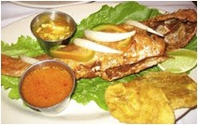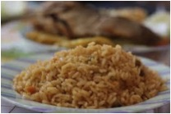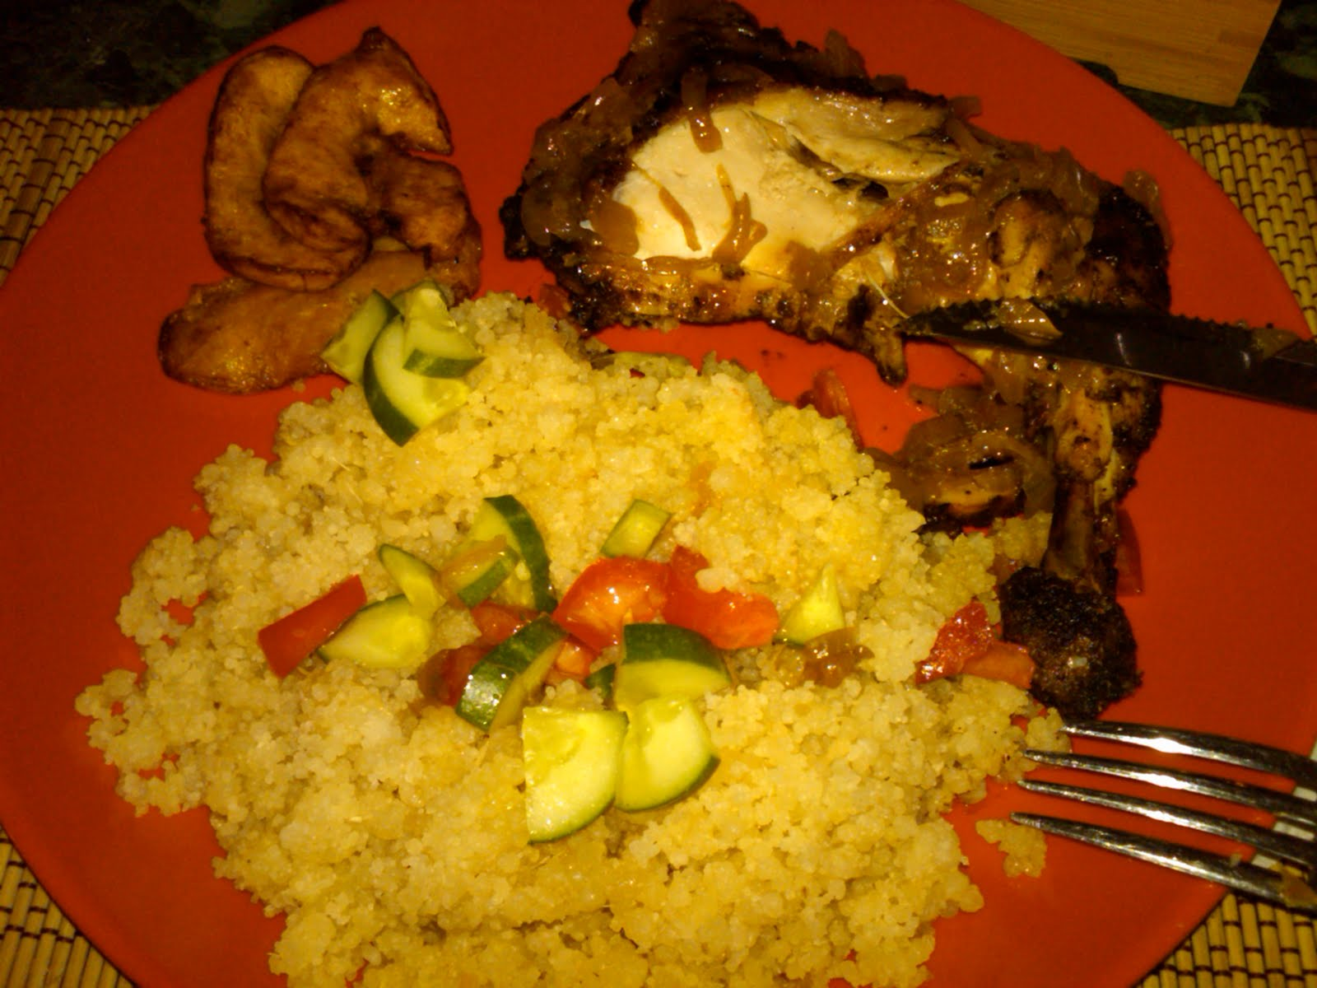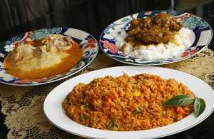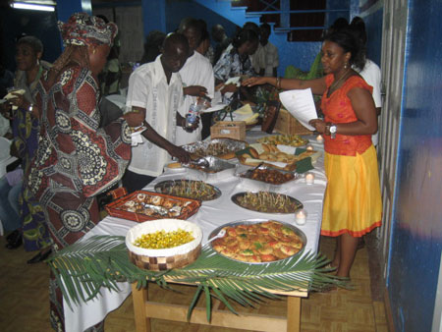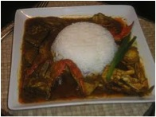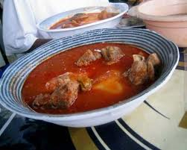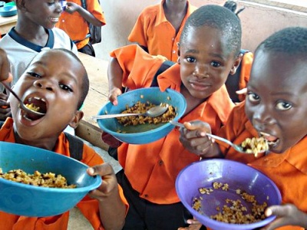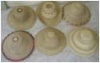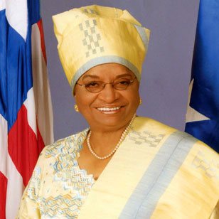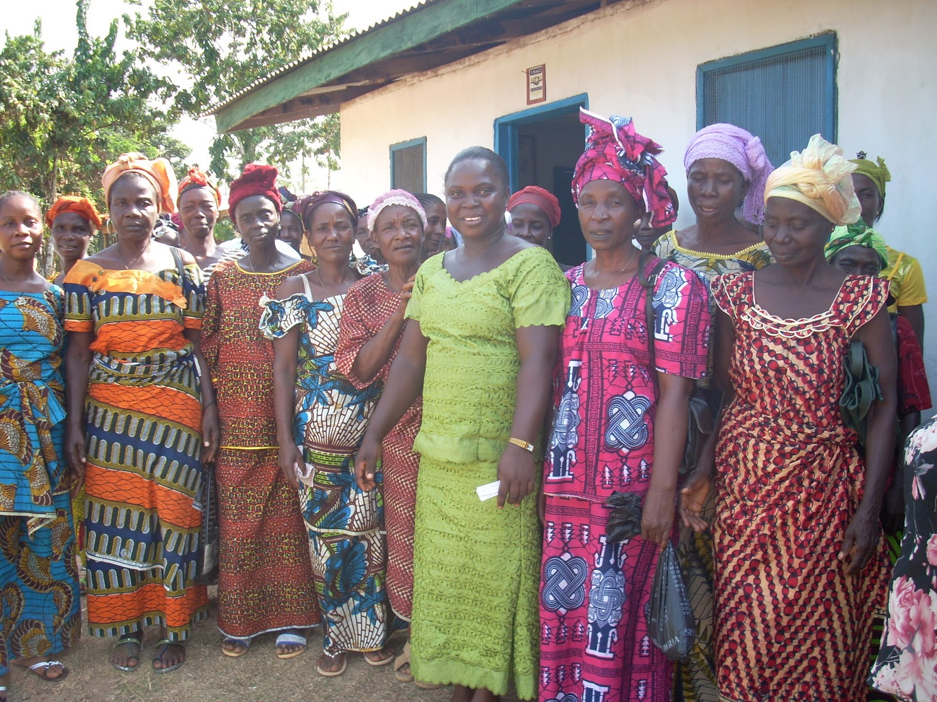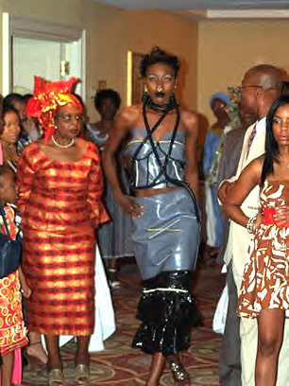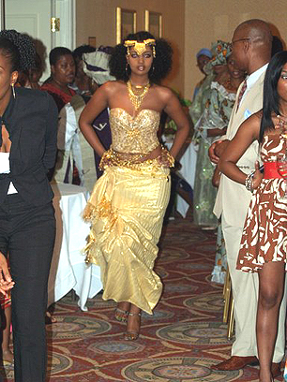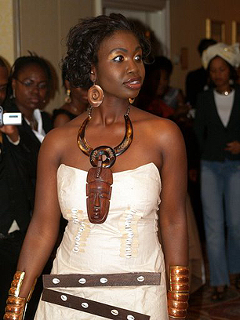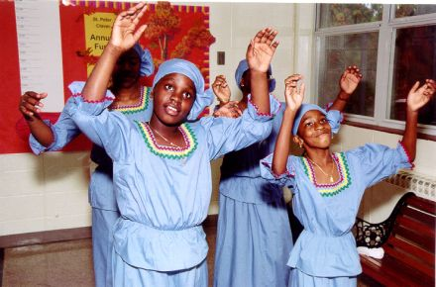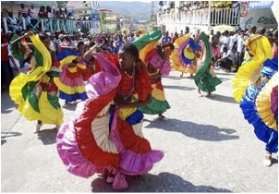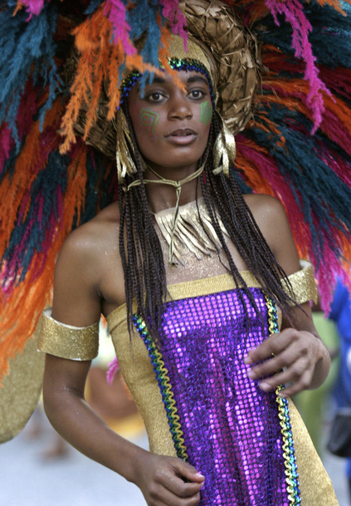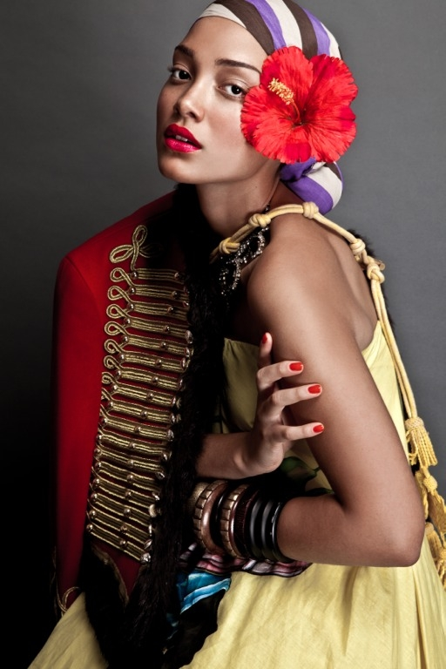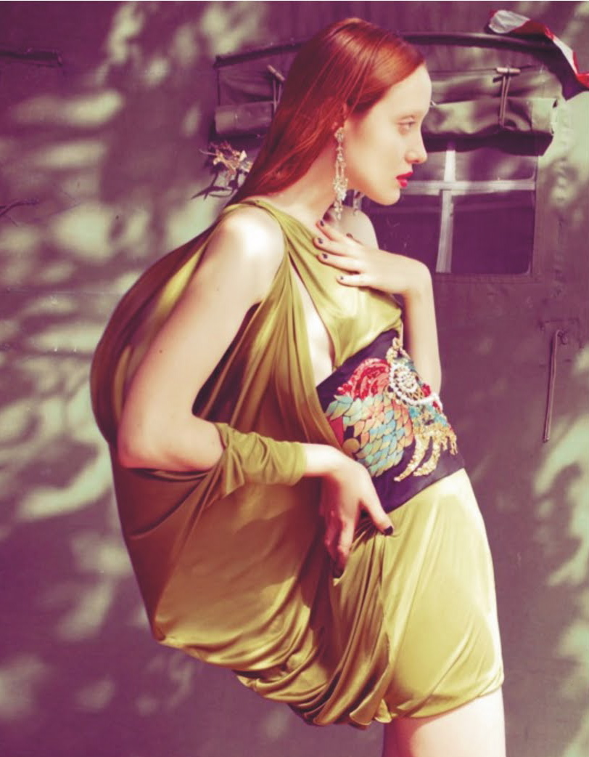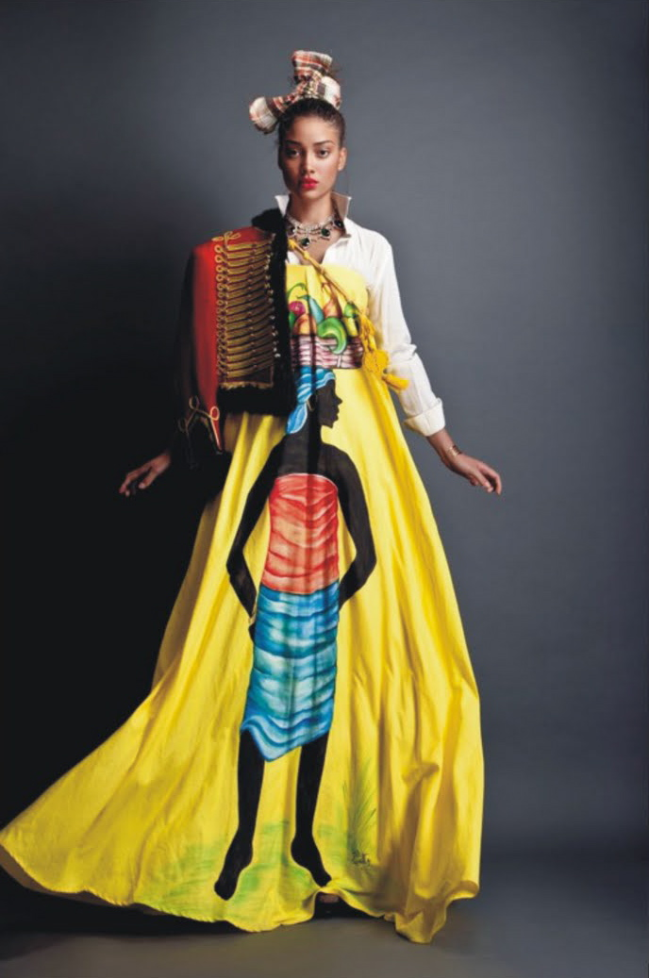

Created by

Mr. Doolittle’s

8th Grade Class

North Miami

Middle School

### Sak Pase A Teenager’s Guide to Culture

Compare and Contrast

Liberia & Haiti

Table of contents

### Introduction p.1

### Art p.2

### Celebration p.6

### Language p.8

### Food p.10

### Fashion p.14

Masks like the ones pictured above are the most prominent in traditional Liberian art. The masks are meant to show powerful warriors, but they are worn mostly during funerals and not during battles. They are traditionally made of wood and use shells, paint, feathers, and other materials to decorate.

Of course there are paintings too, like the one below. Liberians use bright colors, have simple designs, and usually show things that happen every day.

###### Even though there are many different types of art in Liberia, like many countries, the main traditional art form is special masks.

## **Masters of Masks**

Traditional

In our United States History class, we have been learning about many different people and cultures that have played a role in the history of our country.

To better understand culture and the relationships between people, we decided to make a book comparing and contrasting two people and their cultures. We chose Haiti because many of us in our class are from Haiti and want to develop our identity as Haitian Americans. Then we chose Liberia because when we started the project we were studying the African Kingdoms and how they influenced American History.

The Haitian flag is pictured above and the Liberian flag is pictured to the left.

###### When studying history, understanding culture is an essential part to learning about the people and understanding historical events.

## **Studying History through Culture**

Culture

Modern artists in Liberia have not made as many masks as the traditional artists. This might be because the masks were part of the tribal practices and the tribes do not function the same way they did in the past.

The more modern artists have focused more on the paintings. Like the old paintings, they use a lot of colors. However, the new paintings have more detail and mix colors and texture. An example of this is the painting above by Ehi Obinyan. Another example is the painting to the left by John Barbor Bulu.

###### The modern art of Liberia is similar to the traditional art but is reinvented.

###### Haitian art also followed this same evolution.

MOdeRn

## **More Variation and Detail**

Most traditional Haitian artwork shows nature or people in every-day activities or in religious activities.

The painting above left is called *Voudou Dance* and was painted by Luckner Lazard. This painting shows a religious event.

The other painting above is called *Town Meeting* and was made by Lafaille. This is an every-day type of event that happens in a town.

The painting to the left is called *Village Scene* and shows a lot of nature. It was painted by Montas Antoine. Nature is an important part of traditional Haitian life and is in many artworks.

###### Traditional Haitian art has a distinct style that is characterized by bright colors and a two- dimensional design.

Traditional

## Old and New

More abstract art has become more popular in Haiti. The picture to the right is an example of abstract style. It is called *Legacy of the First Sin*.

Some modern Haitian artists have created their own version of the more traditional style. An example is the painting below which was painted by Pierre Zachari.

###### Modern

###### Haitian art has reinvented some aspects of the more traditional art style and combined it with modern ideas.

MODERN

Haiti

Haiti gained independence on January 1, 1804. It was the first black nation to gain independence. The picture above shows the revolution that led to independence. Today, Independence Day is still celebrated on January 1st. The celebration includes parades, fireworks, good food, and parties.

Haitian Flag Day is celebrated on May 18th. On this day, Haitians celebrate pride in their country and its history. Flag Day is celebrated with flags everywhere and parades. The picture below shows a float in a parade on Flag Day.

## Independence Day

## & Flag Day

###### There are many celebrations in Haiti that are also celebrated all over the world. However, two celebrations that are unique to Haiti are Haitian Independence Day and Haitian Flag Day.

###### The Liberian celebrations that are specific to Liberia are kind of like the celebrations in Haiti.

Liberian Independence Day is celebrated on July 26th. They make parties and parades and cook really good food to celebrate. So it is a similar type of celebration to Haiti but is celebrated during a completely different time of year. The picture above shows soldiers in a ceremony for Independence Day.

The Liberians also celebrate Flag Day, like the Haitian people, on August 24th. Just like the Haitians, this celebration shows that the Liberians are proud of their country. The children in the picture to the left are celebrating Flag Day.

In Liberia, President Tubman’s birthday is celebrated on November 29th.

## **Celebrating**

## **With Pride!**

Liberia

Haiti

## **Kreyol**

Everybody speaks Creole but only about 10% of the people are bilingual with French.

In the past, the two languages serve different purposes. Creole is the language of the people and is used in informal things. French has shown high social class and is used in formal situations.

This is changing though because the people are proud of Creole. In 1979 a law was made to let Creole be used in schools. Then, in 1987 the Constitution gave official status to Creole. This language is part of Haitian identity and it is important to respect it as a good language.

###### The two official languages of Haiti are French and Creole (or Kreyol).

Unlike Haiti, there are many languages spoken in Liberia. Even though the official language of Liberia is English, there are 31 languages spoken in Liberia. Some of the main ones are Kpelle, Bassa, and Bandi. The other languages are spoken by small numbers of people throughout the country. Some of these languages have their own alphabet, such as the alphabet pictured above and to the left.

One language the Liberian people speak is a Creole form of English known as Pidgin. This is similar to the Creole spoken in Haiti that originally formed from French.

liberia

###### There are many different languages spoken in Liberia that have developed from indigenous dialects.

## **English…plus 31!**

## **How to Eat…**

###### The traditions and practices for eating are important to Haitian culture.

When eating a meal, the custom is to prepare a large meal and for the whole family to eat in the early evening. Usually breakfast and lunch are smaller meals and less formal. Dinner is the most important meal of the day and everyone gathers for dinner.

Plates are usually prepared and served by the person who cooked, such as the mother. The pictures on this page show what a Haitian dinner table might look like right before eating and how different plates might look after being prepared.

Customs

Typical Haitian food uses a lot of rice and beans, such as the plate of rice in the picture below. Also, Haitian foods use spices like lime and peppers. Haitians eat a lot of fruit, such as plantains and mangoes. Fish is used a lot since Haiti is in the Caribbean. For example, the picture above left shows a meal of fish and bananas.

A very popular and loved Haitian dish is called Soup Joumou, pictured above and right. Soup Joumou is a thick soup made with meat, potatoes, carrots, and sometimes noodles. Sometimes, different people make it different ways. Soup Joumou is mostly prepared for celebrations but is eaten other times too.

Meals

## **What to Eat…**

###### The Republic of Haiti has a distinctive style of cuisine that uses the foods that are found easily in the country.

## **Similar Routines**

###### The Liberian customs for eating and preparing meals are very similar to the Haitian customs.

Most of the time, Liberians eat one large meal a day. This large meal sometimes is during lunch but most of the time is for dinner.

Just like for Haitians, it is important for everyone in the family to be there to eat the meal together. This is especially true during celebrations and holidays.

Also like in Haiti, usually the mother prepares the meals for the family.

Customs

There are many elements of Liberian food that are very similar to Haitian food! Liberians use a lot of rice, just like Haitians. Also the Liberians use plantains and coconuts just like Haitian people. Soups are really popular (like Soup Joumou!).

The Liberian food is different and has its own smell and taste. They use a lot of yams and sweet potatoes. Also, there food is usually extremely spicy. Another thing that is really different about Liberian food is that they do a lot of baking.

## **So Similar to Haitian Food!**

Meals

###### Liberian food and Haitian food have a lot in common! This might be because they have similar weather so the same food is available.

Liberian clothing is usually made from long pieces of fabric that are handspun, hand dyed, and hand woven. They use a lot of bright colors.

Also, it is common for formal clothing to include a matching headdress. The picture above shows Liberian President Ellen Johnson Sirleaf dressed in traditional clothing with a headdress.

The clothing that is worn every day is made from lightweight fabric that is flowing to help keep cool. The women in the picture to the left are wearing this type of clothing, which is similar to the Karabella dresses worn by Haitian women.

###### Traditional Liberian fashion is full of bright colors and functional to keep cool in the hot climate.

## **Dramatic**

Traditional

###### Current fashion in Liberia is very innovative and creative.

Recently, Liberia has been getting attention for the creativity in their fashion. While normal people do not wear many of the styles, the new fashion is very interesting.

For example, Liberian designer Ellen Dunbar created dresses and had a fashion show to celebrate and showcase Liberia’s natural resources. Some of these dresses are pictured here. The model at the left represents Liberia’s rubber, the model above left represents Liberia’s gold, and the model above right represents Liberia’s timber. The fashion show was at Liberia’s embassy and helped to build culture.

## **Creative**

MOdeRn

**The picture at left shows a woman dressed in traditional ceremonial clothing. This style influenced other clothes.**

**Traditional every-day clothes are comfortable and light to keep cool. An example is in the picture below on the right, which shows women wearing Karabella dresses.**

**Traditional dress used for dancing and celebration can be much more colorful and fancy. An example of this type of dress is in the picture of the traditional dancers below on the left.**

## **Rich Colors and Expression**

###### Traditional Haitian clothing can be simple and comfortable or colorful and elaborate.

Traditional

Haiti has high fashion like other countries. Haitian fashion designers are trying to exchange ideas with top designers in Italy and France. Haitian fashion is developing to be very competitive and innovative.

Haitian designer, Stella Jean, created the fashion that is pictured on this page. She uses traditional prints (like the yellow dress above) and traditional clothing (like the military jacket pictured left) and combines this with couture high fashion. Stella Jean also has an organization called Fashion-ABLE that tries to improve the country through fashion. The organization promotes Haitian culture with fashion and uses fashion shows to raise money for victims of the earthquake.

###### Haitian fashion has recently become much more modern and competitive with other countries.

## **Competitive Couture**

MODERN

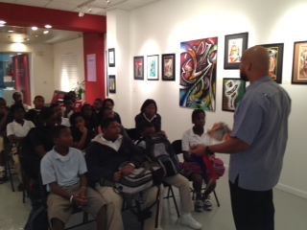

***“Sak Pase: A Teenagers Guide to Culture”* was made possible through the collaborative efforts of the following organizations and individuals:**

**Miami-Dade County Public Schools**

**Mr. Wilbert “Tee” Holloway, School Board Member**

**Mr. Reginald Bonhomme, Chief of Staff**

**North Miami Middle School**

**Mr. Alberto Iber, Principal**

**Mr. Jonathon De Leon, Lead Teacher**

**Mr. Charles Doolittle, 8th Grade Teacher**

**Haitian Heritage Museum**

**Eveline Pierre, Executive Director**

**Serge Rodriguez, Operations Manager**

**Samuel Joseph, Educational Manager**

**Museum Educators**

**Lea Nickless, Bookmaking Artist**

For more information about the Museum Magnet Program and how you can help support its activities, please contact the Haitian Heritage Museum at (305) 371-5988 or email hhmserge@comcast.net.

## **Community Collaboration**

Farah Alezi

Bethsaida Anselme

Marianove Augustin

Marie Augustin

Achena Beniste

Mikely Bolivar

Terry David

Jean Dory

Christella Etienne

Cliff Francois

Smika Frederick

Styvenson Jean-Louis

Lovensky Jemedy

Schneida Jean-  
 Baptiste

Cleefsen Joseph

Jonathan Lalanne

Rodney Liburd

Amelie Louis

Stanley Osias

Ketsia Pierre

Raphael Hugens

###### Our class would like to extend a special thanks to the Haitian Heritage Museum for helping us with our project and teaching us about the importance of culture!

Student Authors of Mr. Doolittle’s 8th Grade Class

###### The Haitian Heritage Museum building our community one block at a time

**The Museum Magnet Program forges strong partnerships with local museums and cultural institutions in Miami-Dade County. Museum educators work side by side with classroom teachers, interfacing the standards-driven curriculum with the objects and artifacts from their respective museums while also facilitating field trips to the museums.**

**This integrated curriculum, focusing primarily on object and project-based learning, emphasizes problem solving, communication, exploration, invention, and inquiry through ongoing visits to the museum and cultural partners.**

**Funding to support the Museum Magnet Program and for the supplies to produce the book was made possible through the generous funding support received from the following organizations:**

**Institute of Museum & Library Services**

**Miami-Dade Cultural Affairs**

**Adopt-A-Classroom**

**Target**

## **Museum Magnet Program**